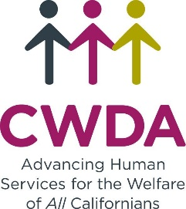
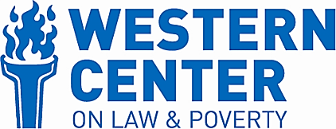
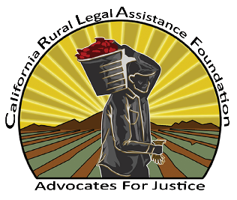
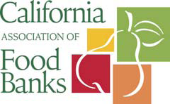
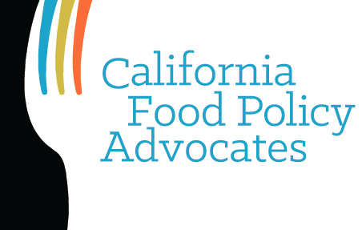

Thursday, December 20, 2018

Today, President Donald J. Trump signed House Resolution 2, the Agriculture Improvement Act of 2018 also known as the Farm Bill. The signature follows an announcement made earlier today that the Administration will request comment on a proposed rule that attempts to end-run Congressional decision-making authority on the country’s most important anti-hunger program, the Supplemental Nutrition Assistance Program (SNAP), known as CalFresh in California, by weakening long-standing protections against work requirements in the program.

The President’s signature comes after two-years of deliberation on national food and farm policy and a significant debate about the role of the SNAP in helping both working and out-of-work Americans, including parents with children in their homes, prevent hunger and maintain employment or prepare to re-enter the workforce. The signed version of the bill that passed last week out of both houses with strong bi-partisan support includes a Nutrition Title with several changes to SNAP—none of which were determined by the Congressional Budget Office to produce savings by cutting access to the program. Congress’ refusal to expand the harsh SNAP 3-month time limit and related work requirement that were proposed by the House version of the Farm Bill was a source of relief for low-income Americans across the country and their advocates. The Administration’s announcement of upcoming regulations on the same issue this week is extremely disappointing, but not unexpected, based on numerous similar attempts over the past two years to circumvent Congressional and Judicial decision-making with proposed policies that make it more difficult for low-income Americans to receive the help they need.

Our organizations are committed to continue working together to prevent cuts to the program and to insist that our national policy makers renew their commitment to end hunger and food insecurity, which more than 40 million Americans struggled with at some time in 2017. With 11.2% of Californians experiencing food insecurity and two of America’s hungriest cities—Bakersfield (1) and Fresno (3)—located in California’s Central Valley, which feeds the world, it is imperative that our state and national leaders endeavor to end hunger. SNAP, our nation’s most important anti-hunger program and California’s first line of defense against hunger, plays a vital role in this effort. We look forward to opportunities to strengthen SNAP and the nutrition safety net that are proven to fight hunger and provide long-term health and economic benefits to our nation.

National Responses to the Administration’s Announcement of the Proposed SNAP Rules on Work Requirements
Center on Budget and Policy Priorities Statement; Center for American Progress Statement
Food Research And Action Center’s Statement; Feeding America’s Statement; and, MAZON: A Jewish Response to Hunger Statement.

Contacts:

Andrew Cheyne, California Association of Food Banks andrew@cafoodbanks.org
Rachel Tucker, California Association of Food Banks rachel@cafoodbanks.org

Jared Call, California Food Policy Advocates jared@cfpa.net

Amagda Perez, California Rural Legal Assistance Foundation aperez@crlaf.org
Noe Paramo, California Rural Legal Assistance Foundation nparamo@crlaf.org

Cathy Senderling-McDonald, County Welfare Directors Association csend@cwda.org

Jessica Bartholow, Western Center on Law and Poverty jbartholow@wclp.org

