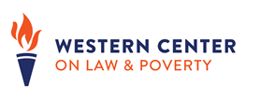
SNAP / CalFresh ABAWD Time Limit
Final Rule Implementation
February 2020

Supplemental Nutrition Assistance Program (SNAP, or CalFresh in California) recipients between the ages of 18 and 49 who do not reside with a child under 18 and do not have a documented disability are deemed to be able-bodied adults without dependents (ABAWD) and may be subject to a 3-month time limit on aid during a 36-month time period.

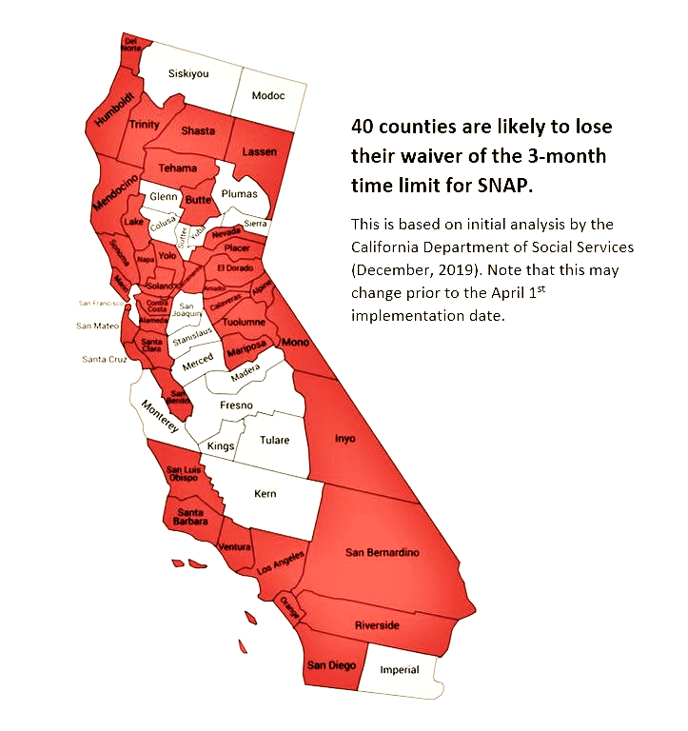
Following federal law and guidance that has been in place for over 20 years, the United States Department of Agriculture (USDA) approved an area waiver to the time limit for all California counties except Alameda, Contra Costa, Marin, San Francisco, Santa Clara and San Mateo until August 31, 2020. However, on December 4, 2019, at the direction of President Donald J. Trump, Secretary of Agriculture Sonny Perdue issued a SNAP Final Rule that increases the number of people subject to the time limit in California and across the country, which will increase hunger and hardship. Here is a link to Western Center’s statement about the new rule.

The California Department of Social Services (DSS) has issued a preliminary assessment of California’s area waiver eligibility based on the new waiver criteria established by the Final Rule, determining that 34 counties will lose the waiver, leaving California with 40 counties without waivers to the 3-month time limit. This assessment, however, cannot be confirmed until the Department completes its final analysis of unemployment using the new standards established in the new rule and a waiver request is ready to be submitted to FNS. The implementation date for new waivers under the Final Rule is April 1, 2020. After that point, SNAP recipients subject to the ABAWD time limit in the counties without an area waiver approved by the USDA will only be eligible for benefits for three full months out of a 36-month period unless they are exempt from work, meet the work requirement or receive one of the “12% discretionary exemptions.”
Map Designed by CAFB – See their ABAWD website at:
California Association of Food Banks – ABAWD Resources

The Final Rule also limits the ability of states to use the statutorily established 12% discretionary exemptions, by removing the ability of states to award recipients unused discretionary exemptions after October 1, 2020, or until they run out, whichever is sooner. DSS is expected to issue guidance instructing counties to use the 12% discretionary exemptions in order to prevent harm among the impacted population and does not yet have an estimated date that they will run out of exemptions they have banked
up to this point. However, they have indicated that this will be difficult to do as the need for exemptions could change significantly during a recession since the Final Rule would also limit a state’s ability to receive prompt relief of the time limit during recessions or periods of high unemployment. DSS and counties have already begun implementing the Final Rule, in order to comply with the tight timeline to implement it.

Litigation has been Filed to Stop the Rule
On January 16, 2020, two separate law suits were filed against the rule and to seek a national injunction. The Attorney General of Washington, D.C. and 13 other states, including California, and New York City filed one case. The Legal Aid of D.C. filed a separate case. These cases have now been joined and they will have a hearing on March 5th. More news will be available after that. Because the rule must be implemented on April 1, 2020, if an injunction is not secured, the state, county and advocate communities will need to do all the work of implementation in order to ensure compliance should that happen. Western Center will keep the CalFresh community appraised about litigation filed and the status of this litigation as well as opportunities to advocate on All County Letters and other implementing documents.

CalFresh ABAWD Time Limit Background
In 1996, through the Personal Responsibility and Work Opportunity Reconciliation Act of 1996 (PRWORA), Congress created a time limit in the Food Stamp Program, now known as the Supplemental Nutrition Assistance Program (SNAP) nationally and as CalFresh in California. This time limit applies to adults between the ages of 18 and 49 years old who are not living with a child, referred to as ABAWDs. Unless exempt due to disability or pregnancy, these recipients are limited to receiving federal food benefits for just 3-months each 36-month period unless they satisfy the 20 hours-per-week work requirement associated with this time limit.

ABAWD Time Limit Makes it More Difficult to Find Work – Not Less
The time limit denies food aid to people who cannot prove that they have worked the requisite number of hours per week. This includes individuals with undiagnosed impairments. States are not obliged to help these individuals find medical providers who can diagnose or treat their impairments. The time limit denies food aid to individuals without impairments who are actively looking for work but unable to find an employer who will hire them or a job that will give them enough hours to comply with the 20-hour per week requirement. Unlike work requirements in other public assistance programs, states have absolutely no obligation under the SNAP time limit rules to offer skills training, employment services or any transportation assistance to individuals before cutting them off food assistance. As a result, most of these individuals are denied food help and go hungry, making it more difficult to find work, not less. The ABAWD population often faces the most significant barriers to work and could benefit from county-administered employment and training placement and barrier removal support services. According to the Center on Budget and Policy Priorities (CBPP), only about half of ABAWDs nationally have a high school diploma or the equivalent.

Working Together to Prevent Hunger & Support Opportunities to Work
While California’s anti-hunger community is unified in our opposition to the time limit and the Administration’s changes to the time limit regulations, we are also committed to ensure that, in regions implementing the time limit, people are protected from the harm of prolonged hunger. This includes supporting robust screening of ABAWD time limited CalFresh recipients to ensure that they are exempted from the rule when appropriate. It also means continuing the work we have pursued for a decade to increase work and work training opportunities for CalFresh recipients so that they have a meaningful path toward complying with the work requirement of the ABAWD time limit and to eventually succeed in exiting poverty through employment. Our state’s anti-hunger community is achieving this by working with state and county administrators and legislators to expand CalFresh Employment & Training (CFET).

Federal Legislation Would End the ABAWD Time Limit Altogether
Even without the Trump Administration’s rule increased the number of people harmed by the SNAP time limit, the rule has been problematic. Western Center and our allies opposed the rule when it was proposed and adopted in the federal Personal Responsibility and Work Opportunity Reconciliation Act (PRWORA) in 1996. This is why we are in full support of House Resolution 1368, introduced by Congresswoman Barbara Lee last year. H.R. 1368 would abolish the time limit rule altogether.

About Western Center on Law and Poverty
Western Center on Law and Poverty leads the fight in the courts, counties, and capital to secure housing, health care and a strong safety net for low-income Californians. Learn more at: www.wclp.org. For more information about our CalFresh policy advocacy, contact:

Jessica Bartholow Antionette Dozier
Email: jbartholow@wclp.org Email: adozier@wclp.org
Phone: (916) 282-5119 Phone: (213) 235-2629

Footnotes

7 Code of Federal Regulation § 273.24 (b) & (f)
Unemployment Compensation Extension Act of 2008 (Public Law 110-449) DOL’s Notice No. 2013-49 issued on December 22, 2013.
ACL 16-24 CalFresh Summary of the ABAWD time limit; MPP 63-410 Work Requirements for ABAWDs; 7 CFR 273.24 Time Limit for Able-Bodied Adults; USDA FNS ABAWD page; CDSS ABAWD Time Limit Handbook: ACL 18-08
Coverage from CalMatters: https://calmatters.org/poverty/2020/01/california-sues-trump-food-stamp-cuts-abawd/
https://oag.ca.gov/news/press-releases/attorney-general-becerra-joins-multistate-lawsuit-challenging-federal-rule and https://oag.dc.gov/release/ag-racine-leads-multistate-lawsuit-stop-trump
Legal Aid of DC’s complaint: https://www.legalaiddc.org/wp-content/uploads/2020/01/Complaint.pdf and motion for preliminary injunction: https://www.legalaiddc.org/wp-content/uploads/2020/01/motion.pdf
Public Law 104-193: http://www.gpo.gov/fdsys/pkg/PLAW-104publ193/html/PLAW-104publ193.htm
7 U.S.C. § 2015 (o); 7 C.F.R. § 273.24; MPP § 63-410.
H.R. 1276 (Rep. Adams, Alma S. [D-NC-12] + 89 Co-sponsors) would require that a job opportunity be provided before benefits cut.
Ed Bolen, “Approximately 1 Million Unemployed Childless Adults Will Lose SNAP Benefits in 2016 as State Waivers Expire Affected Individuals Are Very Poor; Few Qualify for Other Help,” (Jan. 2015) http://www.cbpp.org/cms/?fa=view&id=5251
Public Law 104-193: http://www.gpo.gov/fdsys/pkg/PLAW-104publ193/html/PLAW-104publ193.htm
https://www.congress.gov/bill/116th-congress/house-bill/1368/cosponsors?searchResultViewType=expanded&KWICView=false
Our coalition support letter is: https://wclp.org/wp-content/uploads/2019/05/CA_Orgs_Endorse_ABAWD_SNAP_Repeal_Lee_2019_Logos_Final.pdf

