How to Submit a Letter of Support
Starting in 2019, the California State Legislature has an online system for individuals and organizations to submit letters of support or opposition on current bills.
We’ve created these step-by-step instructions about using the system to submit letters. The instructions include screenshots (pictures) to help describe each step.
We recommend printing or having these instructions open on your computer as you submit your letter.
If you have questions or suggestions, please contact Tracey Patterson at tracey@cfpa.net or 510.433.1122 ext 101.
Set Up an Account
In order to submit a letter, you’ll need to set up an online account with the CA State Legislature. You only need to set up an account one time. This should take less than five minutes.
- Go to: https://calegislation.lc.ca.gov/Advocates/
- When you get to the page, click on “Create an account.”
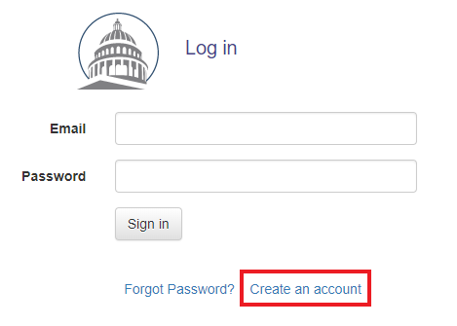
- The button next to “Are you a registered lobbyist?” will be automatically set to “Yes.” Change it by selecting “No.”
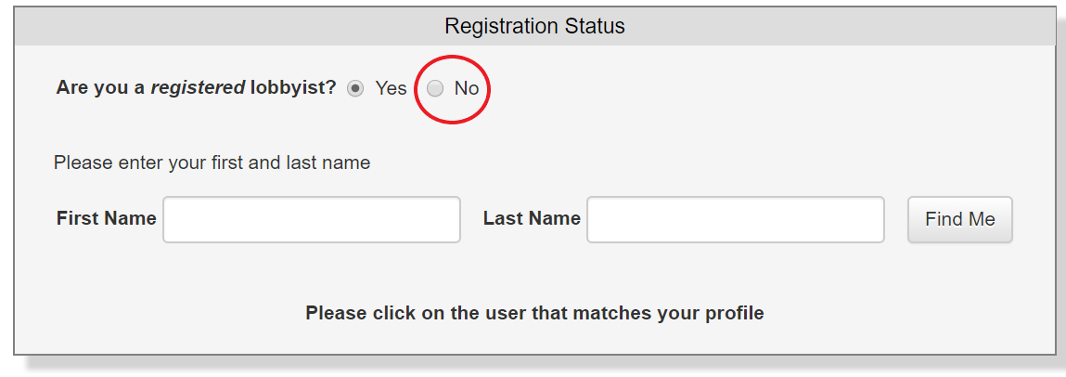
- Enter your first and last names. Your full name is required information. You can enter your address, phone number, and fax number, but that information is NOT required.

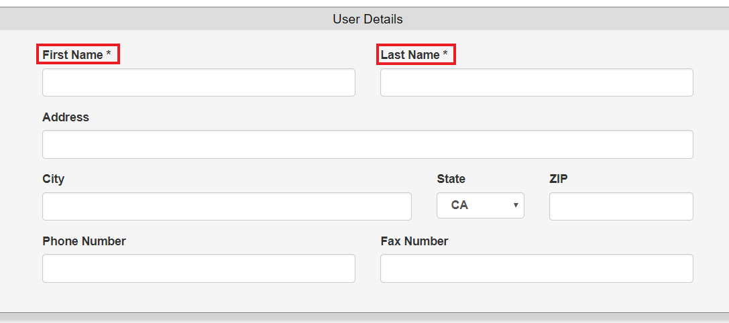
- FOR INDIVIDUALS
If you are setting up an account to submit a letter as an individual, do NOT check the box next to “I am affiliated with an organization.” Even if you are a representative of an organization (staff, volunteer, etc.), leave this unchecked when creating an account to submit a letter as a individual.
FOR ORGANIZATIONS
If you are setting up an account to submit a letter on behalf of your organization, check the box next to “I am affiliated with an organization.”
- Start typing in the name of your organization. The system may display a list of organizational names. Select the name that matches your organization.
If you don’t see your organization listed, go to Step B.
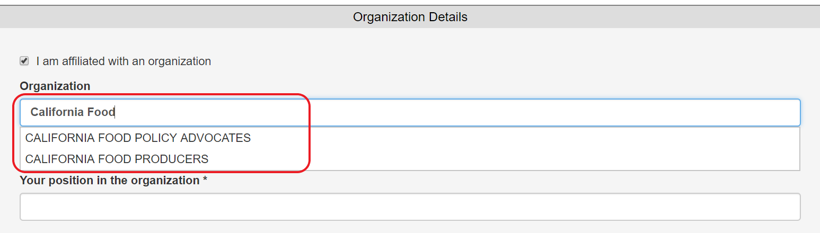
- If your organization is not listed, click “New Organization.”
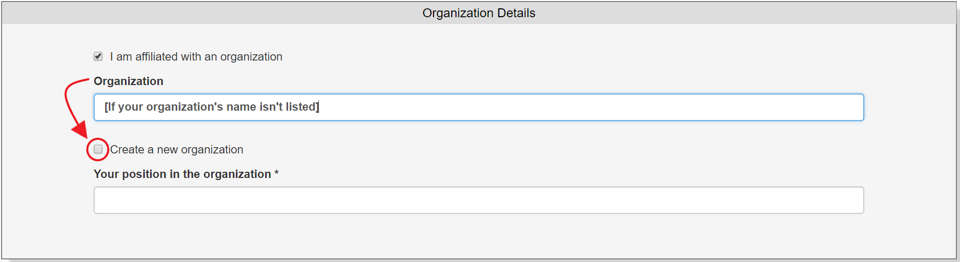
Then type in the name of your organization and your position.
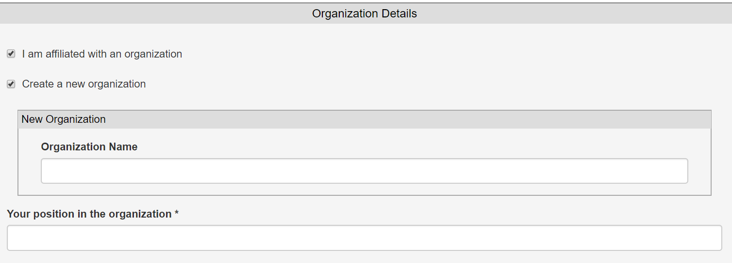
- Type in your email address.
  - Select a security question and type in the answer.
  - Check the box next to “I am not a robot.”
  - Hit “Register.”
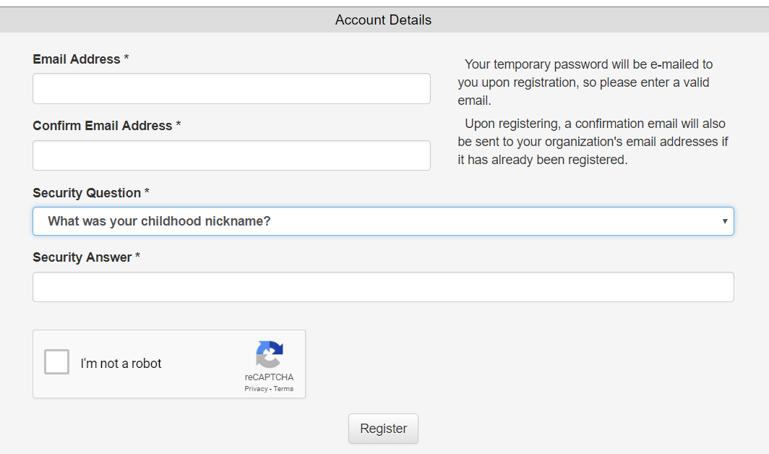

- Once you hit “Register,” you should be sent back to the log-in page. Before you can log in, you need to access your temporary password.
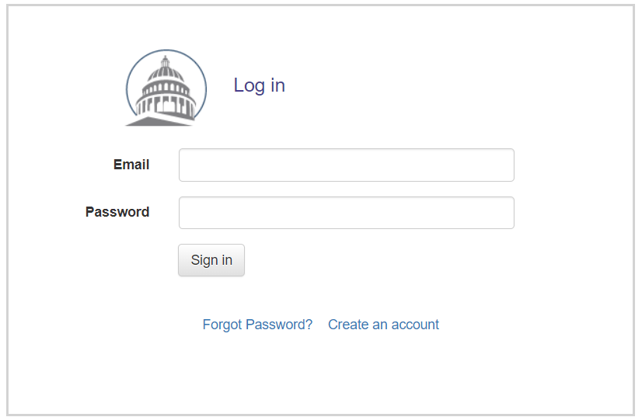
- Go to the email account you provided in the steps above. Check for an email sent by “Advocates Support Team” (California.Advocates@lc.ca.gov). That email will include a temporary password.
- On the log-in page (pictured in Step 7), sign in using your email address and the temporary password.
- You will automatically be asked to select a new password. Type your new password, type the same password again to verify, and hit “Change Password.”
You are now ready to submit your letter!
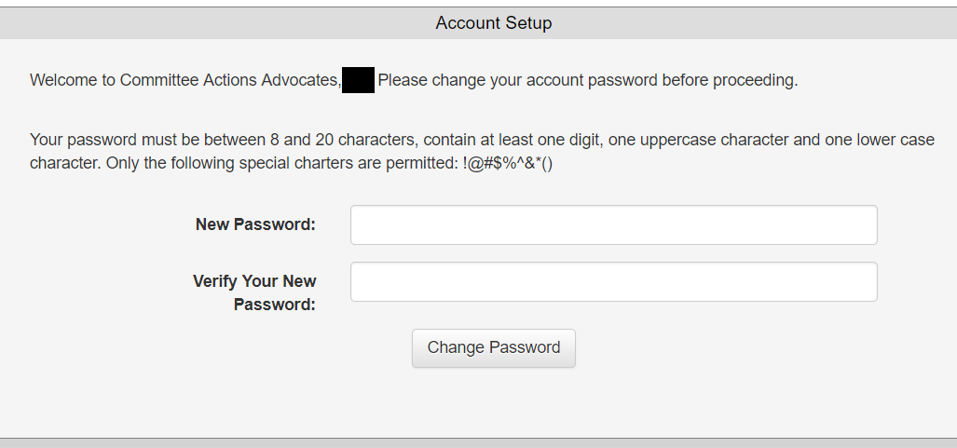

Submit a Letter: Organizations
Organizations and individuals will take different steps to submit a letter. Step-by-step details for organizations are below. You can also access instructions to submit an individual letter.
- Go to: https://calegislation.lc.ca.gov/Advocates/
- Sign into your account using your email address and password.

- Once you sign in, you will enter your homepage. Click on “Submit a Letter.”
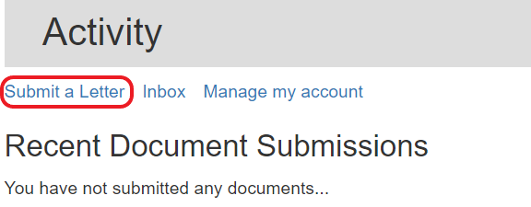
- Select the bill you are writing about. If you want to submit letters for multiple bills, you will submit them one at a time.
Click on the down arrow to select the type of bill. The most common bill types are “SB” (Senate Bill) and “AB” (Assembly Bill).
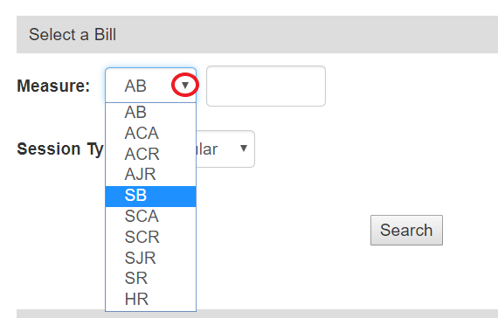

- Type in the bill number and hit “Search.” In this example, we are using the bill SB 285.
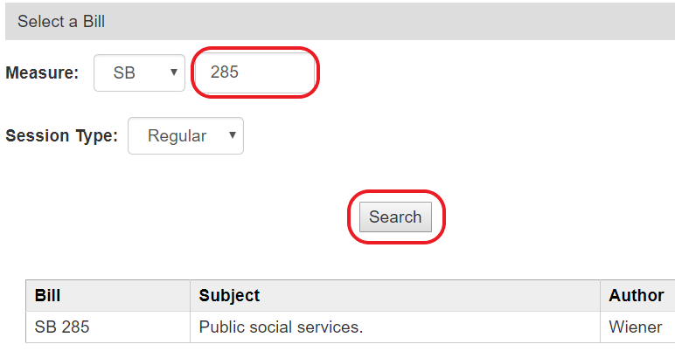
- If more than one version of the bill is listed, select the latest version.
Then click “Next => Select Recipient.”
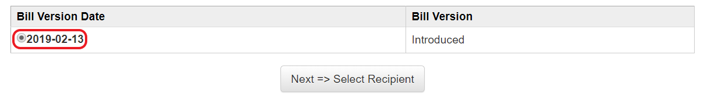
- When the bill has been assigned to a legislative committee, the committee will be listed. In this example, the bill has been assigned to the Senate Human Services Committee.
  - Click to select committee that you want to receive your letter.
  - If applicable, you can also opt to notify the staff of the bill’s author.
  - Click “Next => Select Client”
- Click the box next to the name of your your organization. Then click “Next => Upload Letter”
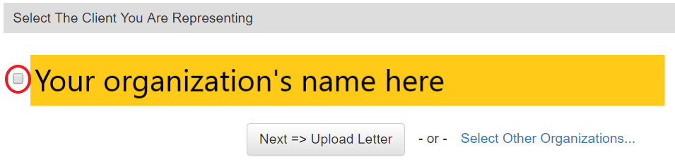

- Select your position on the bill. In this example, we’ve selected “Support.”
  - Type in a subject line. For this example, we’ve typed “SB 285 (Wiener) - Support”
  - Click “Choose File” and select the file that contains your letter.
  - Click “Next => Review Submission”

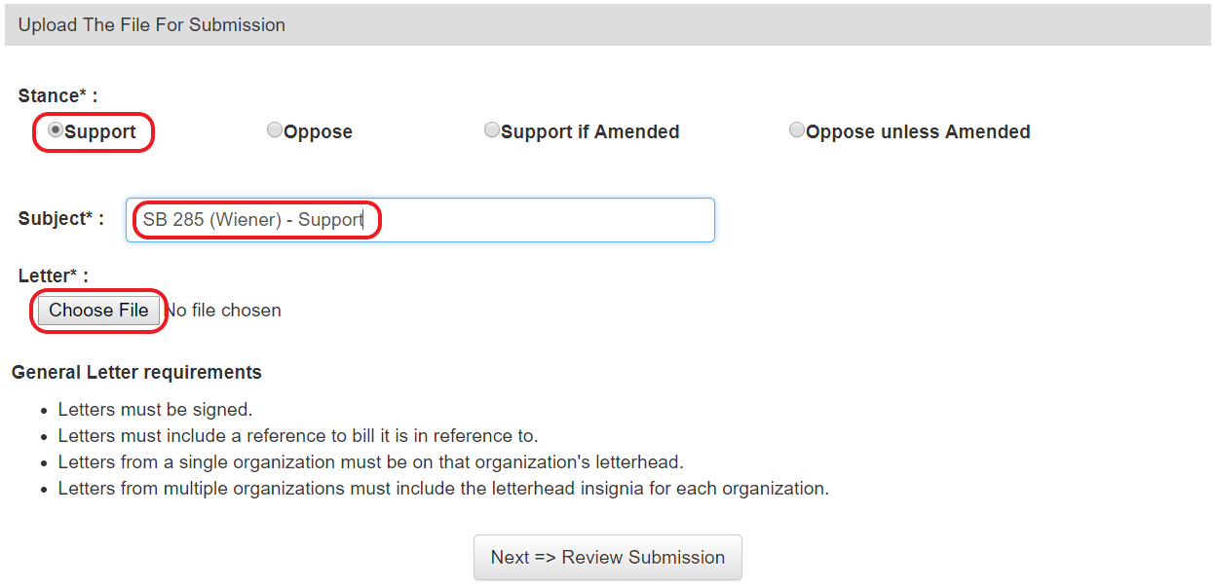

Submit a Letter: Individuals
Organizations and individuals will take different steps to submit a letter. Step-by-step details for individuals are below.
- Go to: https://calegislation.lc.ca.gov/Advocates/
- Sign into your account using your email address and password.
- Once you will sign in, you will enter this page.
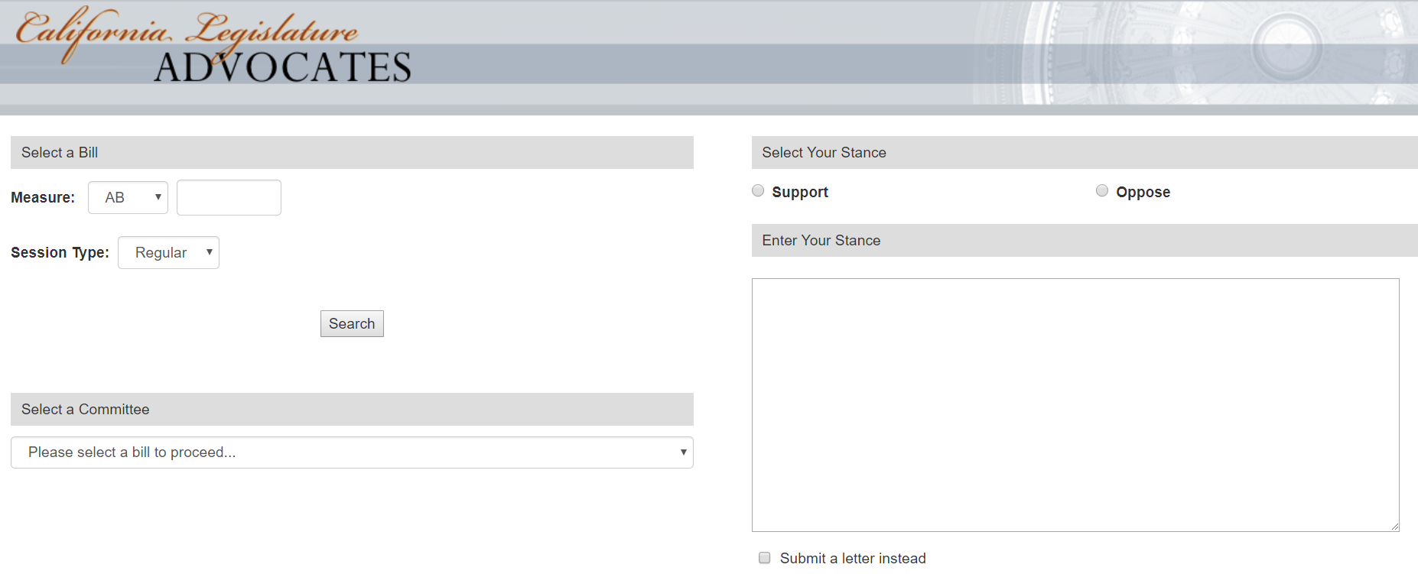
- Select the bill you are writing about. If you want to submit letters for multiple bills, you will submit them one at a time.
Click on the down arrow to select the type of bill. The most common bill types are “SB” (Senate Bill) and “AB” (Assembly Bill).

- Type in the bill number and hit “Search.” In this example, we are using the bill SB 285
- When the bill has been assigned to a legislative committee, the committee will be listed. In this example, the bill has been assigned to the Senate Human Services Committee.
Click on the down arrow and select the committee that you want to receive your letter.
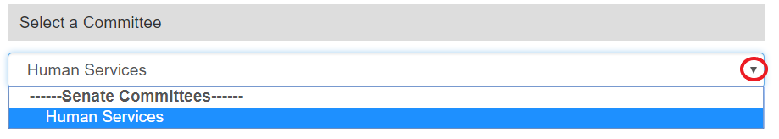
- Select “Support” or “Oppose” to indicate your position on the bill.
In this example, we’ve selected “Support.”
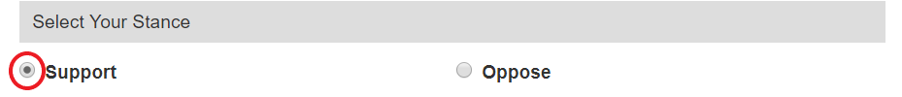
- Type or paste the text of your letter. If you would prefer to attach your letter, click the box next to “Submit a letter instead.”
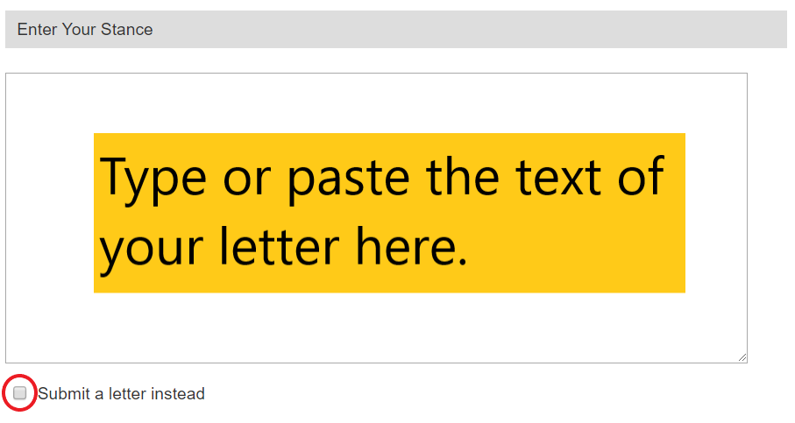

- If you choose to attached your letter, click on “Choose File” and select the file that contains your letter.
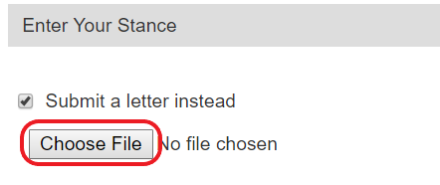
- Click the box next to “I am not a robot.”
Then hit “Submit.”
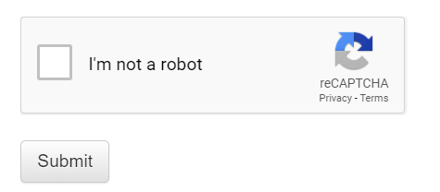
Your letter has been submitted! Thank you for raising your voice about the important issues affecting individuals and families across California.

