Get CalFre!

Now you can have more income and still get CalFresh

If I applied for CalFresh before but my income was too high, should I reapply?
Yes. The income limits for CalFresh went up on October 1, 2021. Use the chart below to see if your income is less than the amount listed for your household size. If it is, you may be able to get CalFresh – even if you applied before and did not qualify. Go to http://getcalfresh.org if you want to apply online.

What are the new income limits?
Use the chart below to see if your income (before taxes) is below the maximum amount. These income amounts are for October 1, 2021 – September 30, 2022.

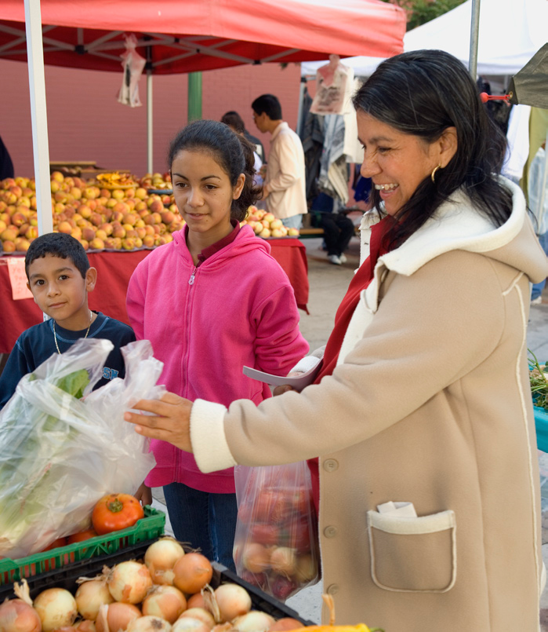
Effective Oct. 1, 2021 – Sept. 30, 2022
Household Size | Maximum Gross Monthly Income (Before Taxes)
1 | $2,148
2 | $2,904
3 | $3,660
4 | $4,418
5 | $5,174
6 | $5,930
7 | $6,688
8 | $7,444
Each additional household member | + $758

Does this apply to everyone?
These income limits apply to most households. It is important to tell the county if you pay for child care. If you are age 60+ or have a disability, it is also important to tell the county about your housing costs and out-of-pocket medical expenses.

I need food. What do I do?
Contact your local food bank. They will be able to tell you where you can get free food in your area. Go to www.cafoodbanks.org or call 510-272-4435 if you need your food bank’s phone number.

